**Angular Integration with Keycloak**

**To Configure with keycloak:-**

Go to keycloak, **Client**, create client with name like xyz and fallow the snap shots for keycloak

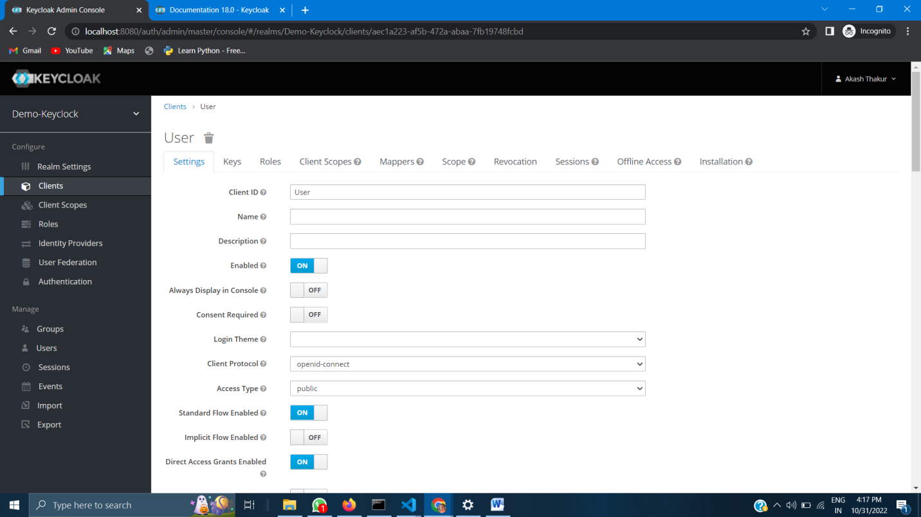

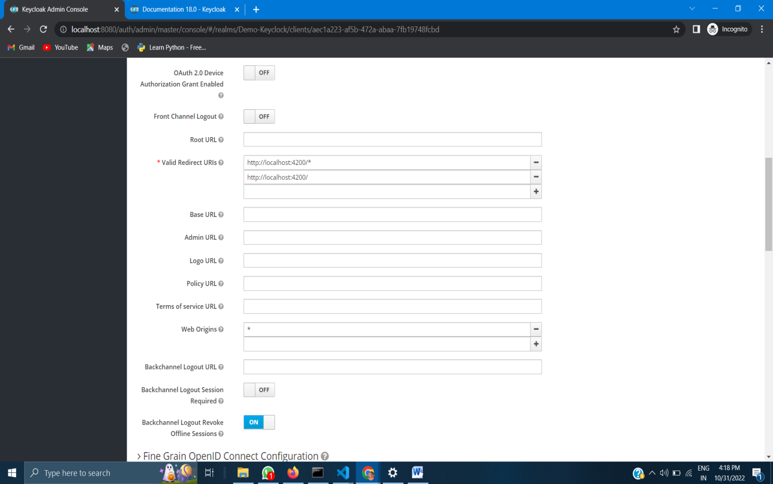

After following the snapshot of the keycloak page save the changes.

And remember the ***client name and realm name***

To do Configuration with Angular:-

Go to angular application which is running fine locate to terminal or open terminal and run this command **npm install keycloak-angular keycloak-js**

After successfully run this command check weather the keyclocak package installed are not for that go to **package json** in angular application

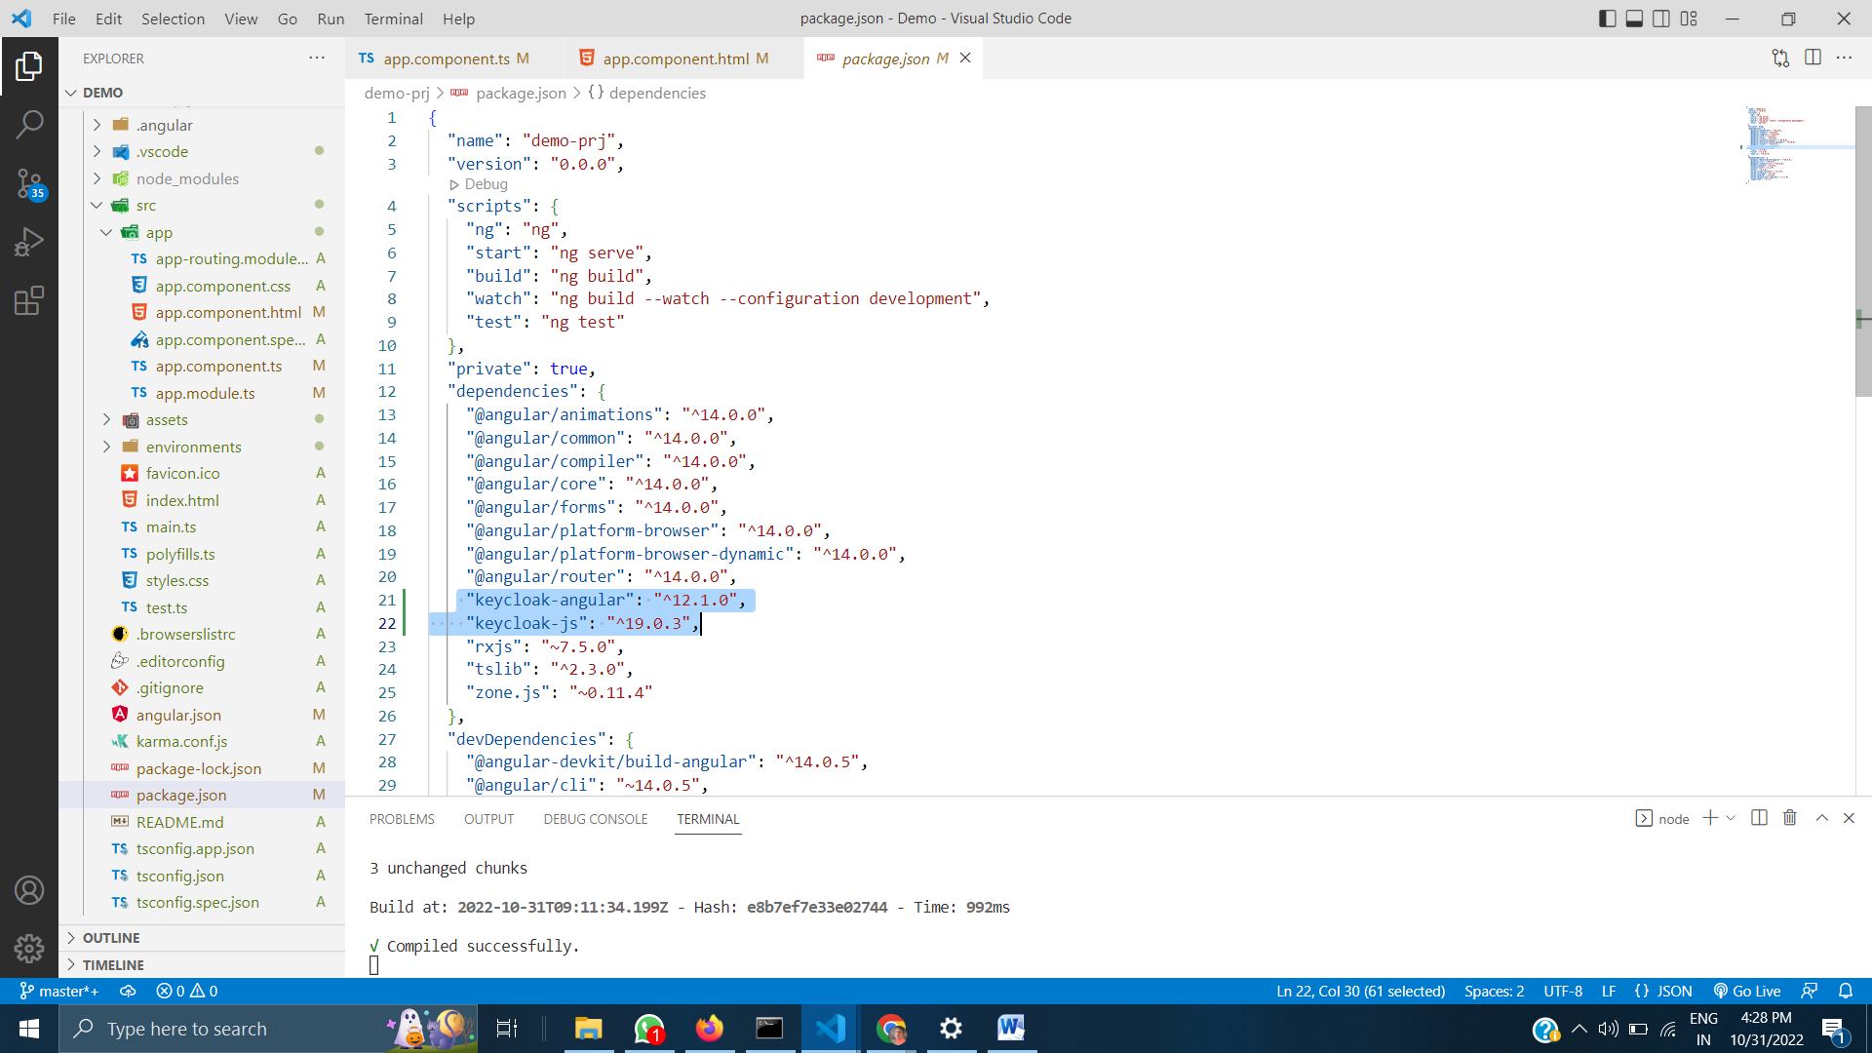

And find this on your angular application if it is there then follow next step

Go to app.module.ts file in angular and paste this on imports

import { KeycloakAngularModule,KeycloakService } from 'keycloak-angular';

next follows this

function initializeKeycloak(keycloak: KeycloakService) {

  return () =>

    keycloak.init({

      config: {

        url: 'http://localhost:8080/auth',

        realm: 'Demo-Keyclock',

        clientId: 'Admin'

      },

      initOptions: {

        onLoad: 'login-required',  // allowed values 'login-required', 'check-sso';

        flow: "standard"          // allowed values 'standard', 'implicit', 'hybrid';

      },

    });

  }

As fallows snap

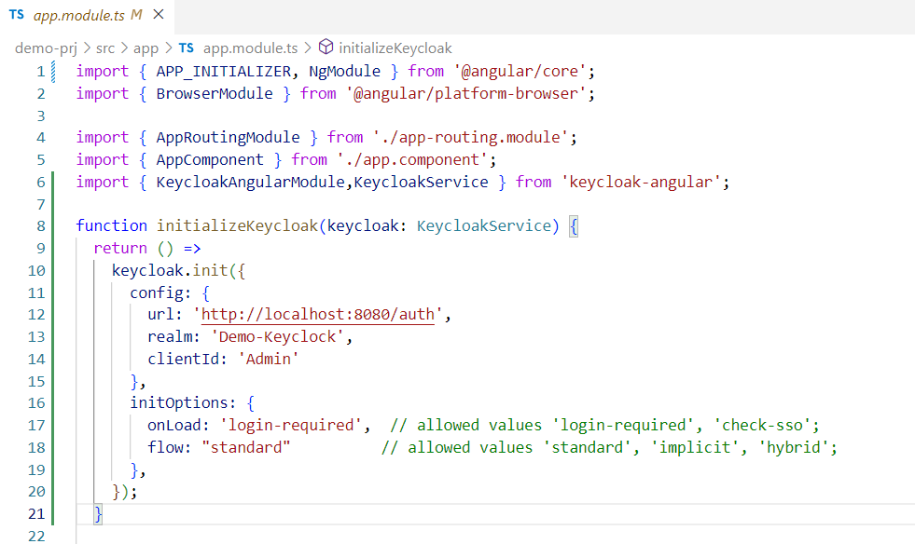

In this you need to change your realm name and clientId

Next import this on @Ngmodules

 KeycloakAngularModule

And write this on providers

providers: [{

    provide: APP_INITIALIZER,

    useFactory: initializeKeycloak,

    multi: true,

    deps: [KeycloakService]

  }],

  bootstrap: [AppComponent]

})

As fallows

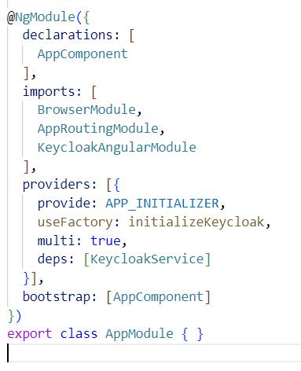

And next step will done in **app.component.ts:-**

Import this:-

import { KeycloakService } from 'keycloak-angular';

and add constructor to the method or a class

like this

 constructor(private keycloak:KeycloakService) { }

  ngOnInit():void {

  }

Or follow as snap

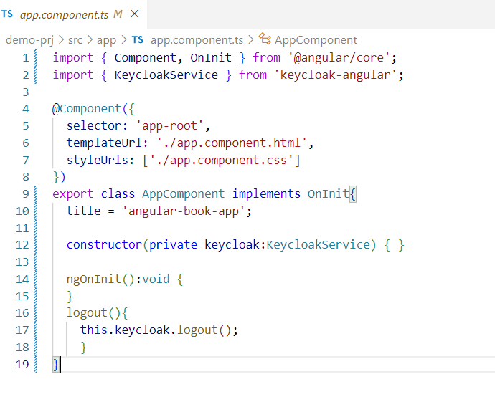

**Finally you done with the keycloak Integration .**